**RESEARCHING IN COMPUTING JOURNAL**

**NAME:-**

**ROLL NO:-**

**CLASS:- M.Sc. IT PART 1 (SEM 1)**

**COLLEGE NAME:-MULUND COLLEGE OF COMMERCE**

**SUBJECT:- RESEARCHING IN COMPUTING PRACTICALS**

**INDEX**

|  |  |  |  |
| --- | --- | --- | --- |
| **Practical No** | | | **Name of the Practical** |
| **1** | **A** | | Write a program for obtaining descriptive  statistics of data. |
| **B** | | Import data from different data sources (from Excel, csv, mysql, sql server, oracle to  R/Python/Excel) |
| **2** | **A** | | Design a survey form for a given case study, collect the primary data and analyse it |
| **B** | | Perform suitable analysis of given secondary  data. |
| **3** | **A** | | Perform testing of hypothesis using one sample  t-test. |
| **B** | | Perform testing of hypothesis using two sample  t-test |
| **C** | | Perform testing of hypothesis using paired t-test. |
| **4** | **A** | | Perform testing of hypothesis using chi-squared  goodness-of-fit test. |
| **B** | | Perform testing of hypothesis using chi-squared  Test of Independence |
| **5** |  | | Perform testing of hypothesis using Z-test. |
| **6** | **A** | | Perform testing of hypothesis using one-way ANOVA |
| **B** | | Perform testing of hypothesis using two-way  ANOVA. |
| **C** | | Perform testing of hypothesis using multivariate  ANOVA (MANOVA). |
| **7** | **A** | | Perform the Random sampling for the given  data and analyse it. |
| **B** | | Perform the Stratified sampling for the given  data and analyse it. |
| **8** | | | Compute different types of correlation. |
| **9** | | **A** | Perform linear regression for prediction. |
| **B** | Perform polynomial regression for prediction. |
| **10** | | **A** | Perform multiple linear regression. |
| **B** | Perform Logistic. regression |

**Practical 1:**

1. **Write a program for obtaining descriptive statistics of data.**

**Code-**

import pandas as pd

#Create a Dictionary of series

d = {'Age':pd.Series([25,26,25,23,30,29,23,34,40,30,51,46]), 'Rating':pd.Series([4.23,3.24,3.98,2.56,3.20,4.6,3.8,3.78,2.98,4.80,4.10,3.65])}

#Create a DataFrame df = pd.DataFrame(d)

print(df) print('############ Sum ########## ')

print (df.sum())

print('############ Mean ########## ')

print (df.mean())

print('############ Standard Deviation ########## ') print (df.std()) print('############ Descriptive Statistics ########## ') print (df.describe()

**Output-**

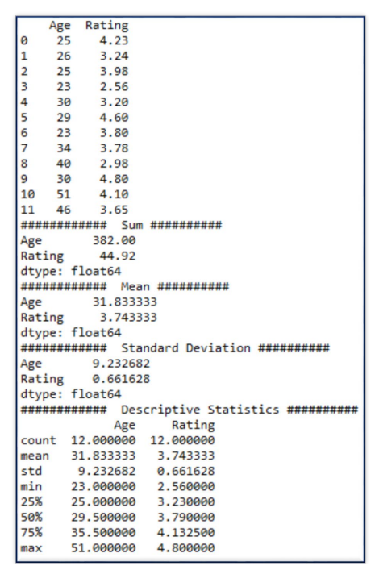

#### Using Excel

Go to File Menu → Options → Add-Ins→ Select Analysis ToolPak→ Press OK

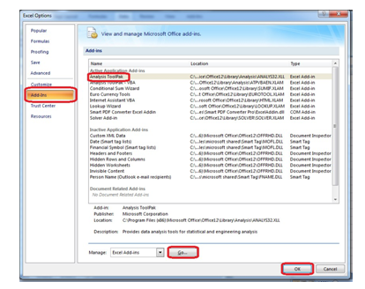

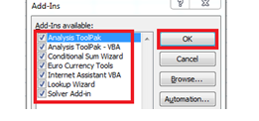

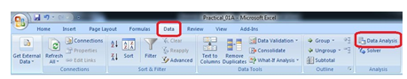

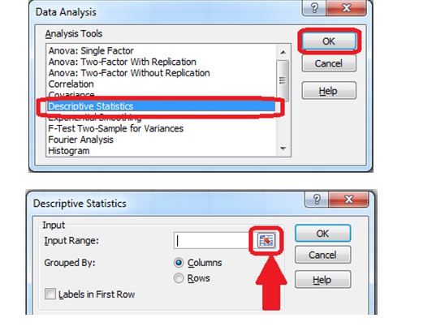

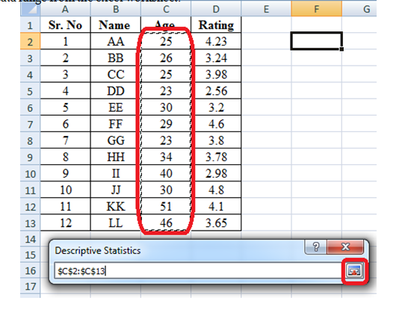

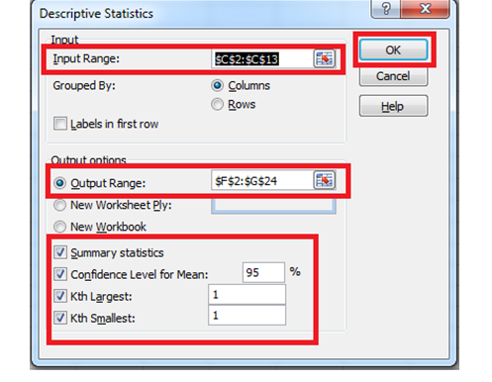

**Output-**

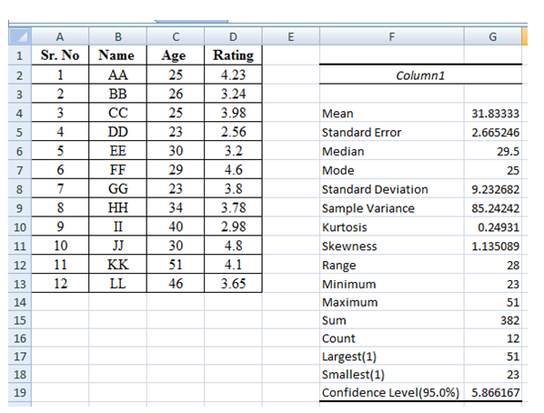

## Import data from different data sources (from Excel, csv, mysql, sql server, oracle to R/Python/Excel)

SQLite:

import sqlite3 as sq import pandas as pd

################################################################

Base='C:/VKHCG'

sDatabaseName=Base + '/01-Vermeulen/00-RawData/SQLite/vermeulen.db' conn = sq.connect(sDatabaseName) ################################################################

sFileName='C:/VKHCG/01-Vermeulen/01-Retrieve/01-EDS/02-Python/Retrieve_IP_DATA.csv' print('Loading :',sFileName) IP_DATA_ALL_FIX=pd.read_csv(sFileName,header=0,low_memory=False) IP_DATA_ALL_FIX.index.names = ['RowIDCSV']

sTable='IP_DATA_ALL'

print('Storing :',sDatabaseName,' Table:',sTable) IP_DATA_ALL_FIX.to_sql(sTable, conn, if_exists="replace")

print('Loading :',sDatabaseName,' Table:',sTable) TestData=pd.read_sql_query("select * from IP_DATA_ALL;", conn) print('################')

print('## Data Values')

print('################')

print(TestData)

print('################')

print('## Data Profile')

print('################')

print('Rows :',TestData.shape[0])

print('Columns :',TestData.shape[1]) print('################')

print('### Done!! ############################################')

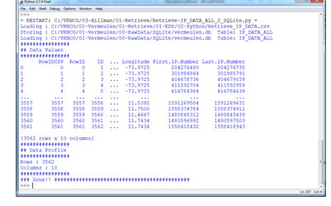

**MySQL:**

Open MySql

Create a database “DataScience”

Create a python file and add the following code:

################ Connection With MySQL ######################

importmysql.connector

conn = mysql.connector.connect(host='localhost', database='DataScience',

user='root', password='root') conn.connect if(conn.is_connected):

print('###### Connection With MySql Established Successfullly ##### ') else:

print('Not Connected -- Check Connection Properites')

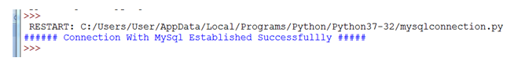

Microsoft Excel

##################Retrieve-Country-Currency.py ################################################################

# -*- coding: utf-8 -*- ################################################################

importos

import pandas as pd

################################################################

Base='C:/VKHCG'

################################################################

sFileDir=Base + '/01-Vermeulen/01-Retrieve/01-EDS/02-Python'

#if not os.path.exists(sFileDir):

#os.makedirs(sFileDir)

################################################################

CurrencyRawData = pd.read_excel('C:/VKHCG/01-Vermeulen/00-RawData/Country_Currency.xlsx')

sColumns = ['Country or territory', 'Currency', 'ISO-4217']

CurrencyData = CurrencyRawData[sColumns]

CurrencyData.rename(columns={'Country or territory': 'Country', 'ISO-4217':

'CurrencyCode'}, inplace=True)

CurrencyData.dropna(subset=['Currency'],inplace=True)

CurrencyData['Country'] = CurrencyData['Country'].map(lambda x: x.strip())

CurrencyData['Currency'] = CurrencyData['Currency'].map(lambda x: x.strip())

CurrencyData['CurrencyCode'] = CurrencyData['CurrencyCode'].map(lambda x: x.strip())

print(CurrencyData)

print('~~~~~~ Data from Excel Sheet Retrived Successfully ~~~~~~~ ')

sFileName=sFileDir + '/Retrieve-Country-Currency.csv'

CurrencyData.to_csv(sFileName, index = False)

**OUTPUT:**

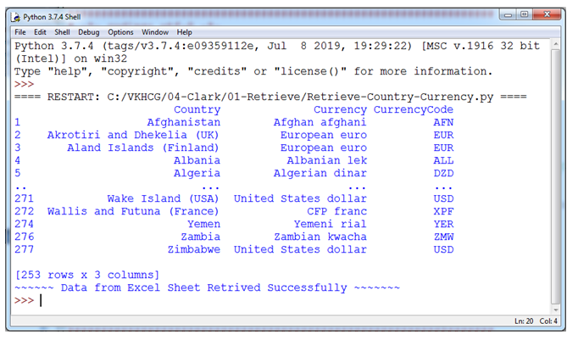

# Practical 2:

## Design a survey form for a given case study, collect the primary data and analyse it.

## Perform analysis of given secondary data.

### Steps in Secondary Data Analysis

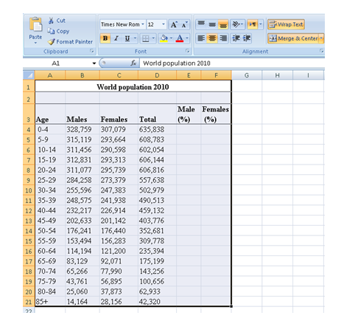

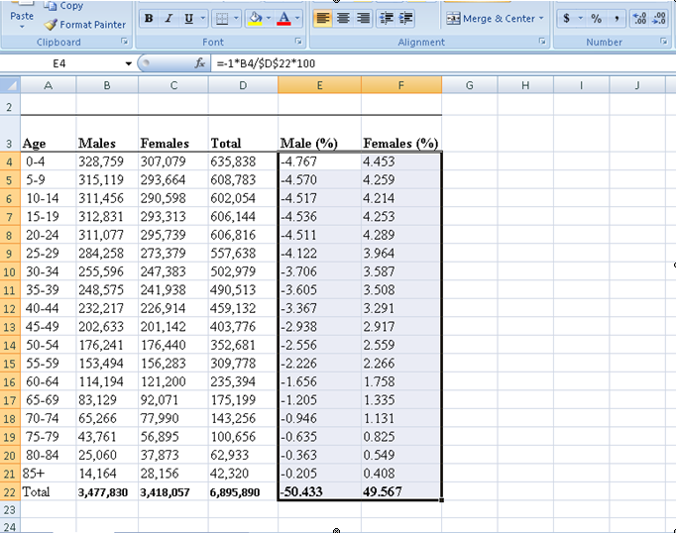

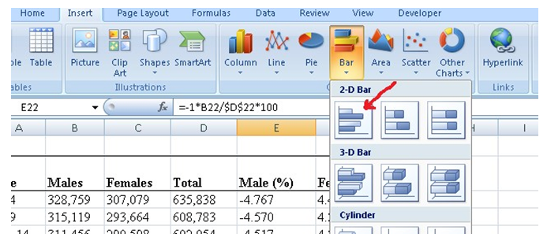

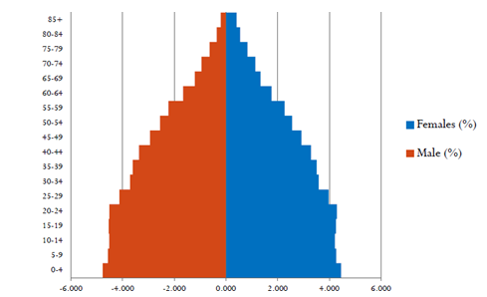

# Practical 3:

## Perform testing of hypothesis using one sample t-test.

#### Program Code:

# -*- coding: utf-8 -*- """

Created on Mon Dec 16 18:01:46 2019 @author: Ahtesham Shaikh

"""

fromscipy.stats import ttest_1samp importnumpy as np

ages = np.genfromtxt('ages.csv') print(ages)

ages_mean = np.mean(ages) print(ages_mean)

tset, pval = ttest_1samp(ages, 30) print('p-values - ',pval)

if pval< 0.05: # alpha value is 0.05

print(" we are rejecting null hypothesis")

else:

print("we are accepting null hypothesis")

#### Output:

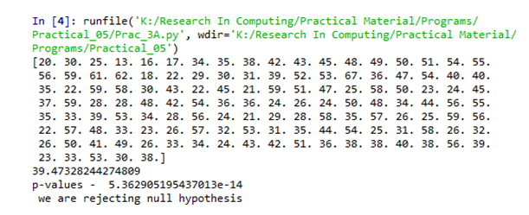

## Write a program for t-test comparing two means for independent samples.

**Two Sample t Test**

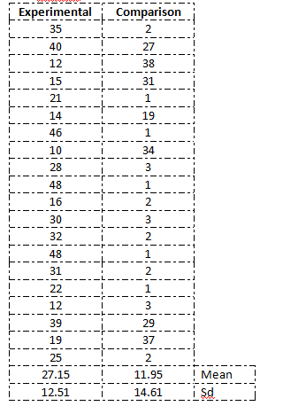

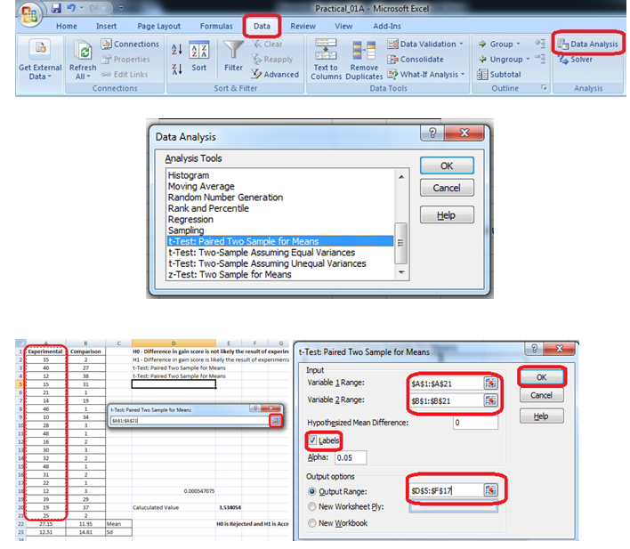

#### Output:

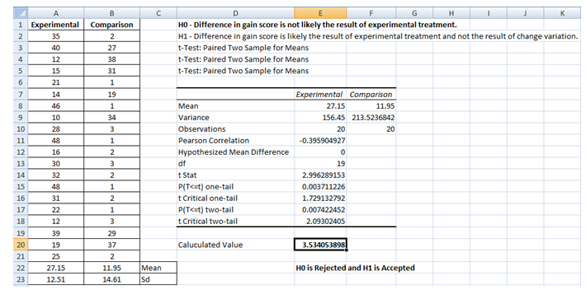

#### Using Python

importnumpy as np fromscipy import stats

fromnumpy.random import randn N = 20

#a = [35,40,12,15,21,14,46,10,28,48,16,30, 32,48,31,22,12,39,19,25]

#b = [2,27,31,38,1,19,1,34,3,1,2,1,3,1,2,1,3,29,37,2]

a = 5 * randn(100) + 50 b = 5 * randn(100) + 51 var_a = a.var(ddof=1) var_b = b.var(ddof=1)

s = np.sqrt((var_a + var_b)/2)

t = (a.mean() - b.mean())/(s*np.sqrt(2/N))

df = 2*N - 2

#p-value after comparison with the t p = 1 - stats.t.cdf(t,df=df)

print("t = " + str(t)) print("p = " + str(2*p)) if t> p :

print('Mean of two distribution are differnt and significant') else:

print('Mean of two distribution are same and not significant')

#### Output:

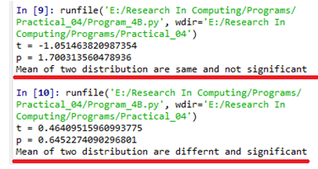

## Perform testing of hypothesis using paired t-test.

#### Program Code:

from scipy import stats

import matplotlib.pyplot as plt

import pandas as pd

df = pd.read_csv("blood_pressure.csv")

print(df[['bp_before','bp_after']].describe())

#First let’s check for any significant outliers in

#each of the variables.

df[['bp_before', 'bp_after']].plot(kind='box') # This saves the plot as a png file

plt.savefig('boxplot_outliers.png')

# make a histogram to differences between the two scores.

df['bp_difference'] = df['bp_before'] - df['bp_after']

df['bp_difference'].plot(kind='hist', title= 'Blood Pressure Difference Histogram') #Again, this saves the plot as a png file

plt.savefig('blood pressure difference histogram.png')

stats.probplot(df['bp_difference'], plot= plt)

plt.title('Blood pressure Difference Q-Q Plot')

plt.savefig('blood pressure difference qq plot.png')

stats.shapiro(df['bp_difference'])

stats.ttest_rel(df['bp_before'], df['bp_after'])

#### Output:

#### 

# Practical 4:

## Perform testing of hypothesis using chi-squared goodness- of-fit test.

H0 : The population distribution of the variable is the same as the proposed distribution HA : The distributions are different

To calculate the Chi –Squred value for Windows go to cell D2 and type =((B2- C2)*(B2-C2))/C2

To calculate the Chi –Squred value for Mac go to cell D3 and type =((B3-C3)*(B3- C3))/C3

To calculate the Chi –Squred value for Mac go to cell D3 and type =((B4-C4)*(B4- C4))/C4

Go to Cell D5 for and type=SUM(D2:D4)

To get the table value for Chi-Square for α = 0.05 and dof = 2, go to cell D7 and type

=CHIINV(0.05,2)

At cell D8 type =IF(D5>D7, "H0 Accepted","H0 Rejected")

#### Output:

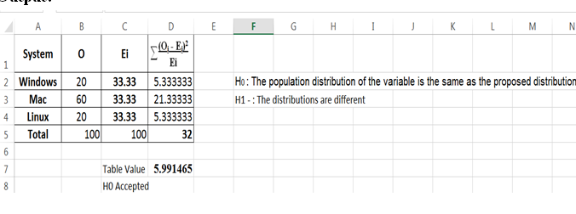

## Perform testing of hypothesis using chi-squared test of independence.

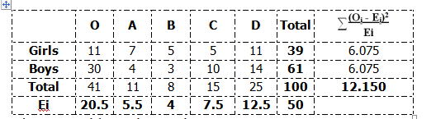

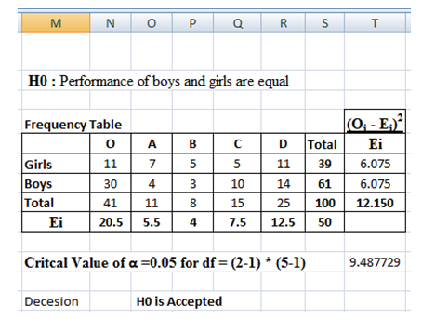

#### Using Python

importnumpy as np

import pandas as pd

importscipy.stats as stats

np.random.seed(10)

stud_grade = np.random.choice(a=["O","A","B","C","D"],

p=[0.20, 0.20 ,0.20, 0.20, 0.20], size=100)

stud_gen = np.random.choice(a=["Male","Female"], p=[0.5, 0.5], size=100)

mscpart1 = pd.DataFrame({"Grades":stud_grade, "Gender":stud_gen})

print(mscpart1)

stud_tab = pd.crosstab(mscpart1.Grades, mscpart1.Gender, margins=True)

stud_tab.columns = ["Male", "Female", "row_totals"]

stud_tab.index = ["O", "A", "B", "C", "D", "col_totals"]

observed = stud_tab.iloc[0:5, 0:2 ]

print(observed)

expected = np.outer(stud_tab["row_totals"][0:5], stud_tab.loc["col_totals"][0:2]) / 100 print(expected)

chi_squared_stat = (((observed-expected)**2)/expected).sum().sum()

print('Calculated : ',chi_squared_stat)

crit = stats.chi2.ppf(q=0.95, df=4)

print('Table Value : ',crit)

ifchi_squared_stat>= crit: print('H0 is Accepted ') else:

print('H0 is Rejected ')

**Output:**

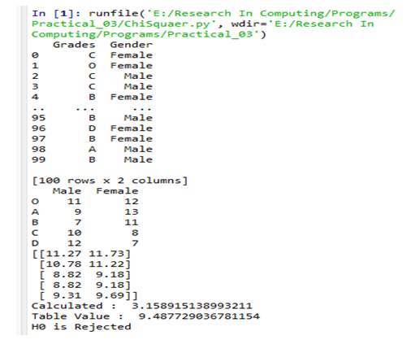

# Practical 5:

## Perform testing of hypothesis using Z-test.

### Program Code for one-sample Z test.

from statsmodels.stats

import weightstats as stests

import pandas as pd

from scipy import stats

df = pd.read_csv("blood_pressure.csv")

df[['bp_before','bp_after']].describe() print(df)

ztest ,pval = stests.ztest(df['bp_before'], x2=None, value=156)

print(float(pval))

if pval<0.05:

print("reject null hypothesis")

else:

print("accept null hypothesis")

#### Output:

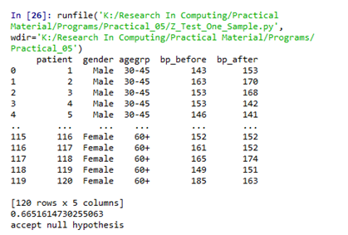

**Two-sample Z test**

import pandas as pd

from statsmodels.stats import weightstats as stests

df = pd.read_csv("blood_pressure.csv")

df[['bp_before','bp_after']].describe()

print(df)

ztest ,pval = stests.ztest(df['bp_before'], x2=df['bp_after'], value=0,alternative='two- sided')

print(float(pval))

if pval<0.05:

print("reject null hypothesis")

else:

print("accept null hypothesis")

**Output:**

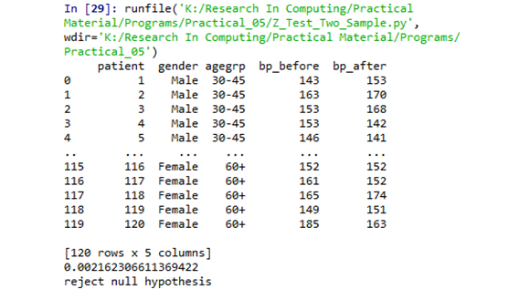

# Practical 6:

## Perform testing of hypothesis using One-way ANOVA.

**Code:**

import pandas as pd

importnumpy as np

importmatplotlib.pyplot as plt

importseaborn as sns fromscipy

import stats

data = pd.read_csv("scores.csv")

data.head()

data['Borough'].value_counts()

#### ############### There is no total score column, have to create it.

**########In addition, find the mean score of the each district across all schools.**

data['total_score'] = data['Average Score (SAT Reading)'] + \ data['Average Score (SAT Math)'] + \

data['Average Score (SAT Writing)']

data = data[['Borough', 'total_score']].dropna()

x = ['Brooklyn', 'Bronx', 'Manhattan', 'Queens', 'Staten Island'] district_dict = {}

#Assigns each test score series to a dictionary key for district in x:

district_dict[district] = data[data['Borough'] == district]['total_score']

y = []

yerror = []

#Assigns the mean score and 95% confidence limit to each district for district in x:

y.append(district_dict[district].mean()) yerror.append(1.96*district_dict[district].std()/np.sqrt(district_dict[district].shape[0])) print(district + '_std : {}'.format(district_dict[district].std()))

sns.set(font_scale=1.8)

fig = plt.figure(figsize=(10,5))

ax = sns.barplot(x, y, yerr=yerror) ax.set_ylabel('Average Total SAT Score') plt.show()

#### ###################### Perform 1-way ANOVA

print(stats.f_oneway(

district_dict['Brooklyn'], district_dict['Bronx'], \ district_dict['Manhattan'], district_dict['Queens'], \ district_dict['Staten Island']

))

districts = ['Brooklyn', 'Bronx', 'Manhattan', 'Queens', 'Staten Island'] ss_b = 0

for d in districts:

ss_b += district_dict[d].shape[0] * \ np.sum((district_dict[d].mean() - data['total_score'].mean())**2)

ss_w = 0

for d in districts:

ss_w += np.sum((district_dict[d] - district_dict[d].mean())**2)

msb = ss_b/4

msw = ss_w/(len(data)-5) f=msb/msw

print('F_statistic: {}'.format(f))

ss_t = np.sum((data['total_score']-data['total_score'].mean())**2) eta_squared = ss_b/ss_t

print('eta_squared: {}'.format(eta_squared))

#### Output:

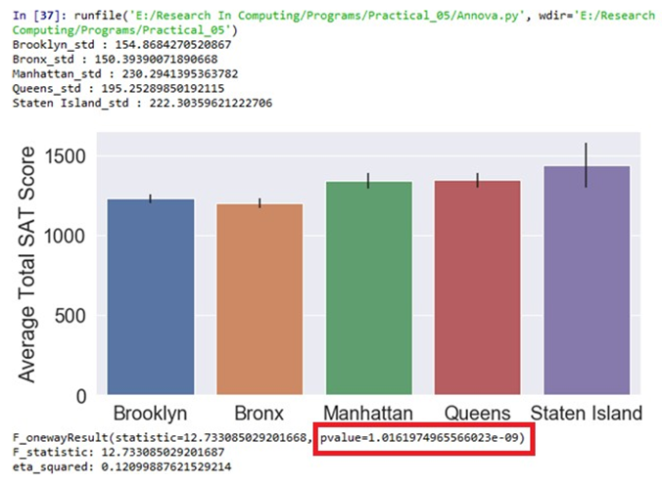

# Using Excel

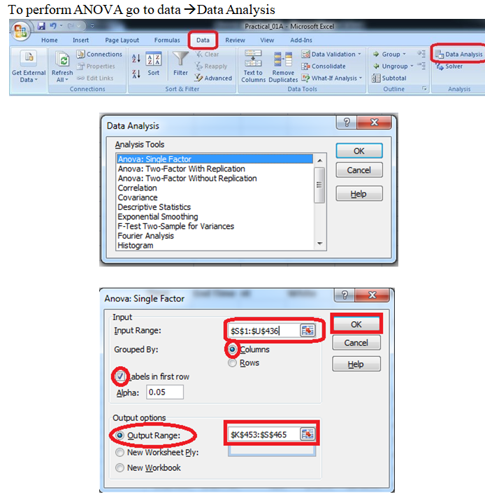

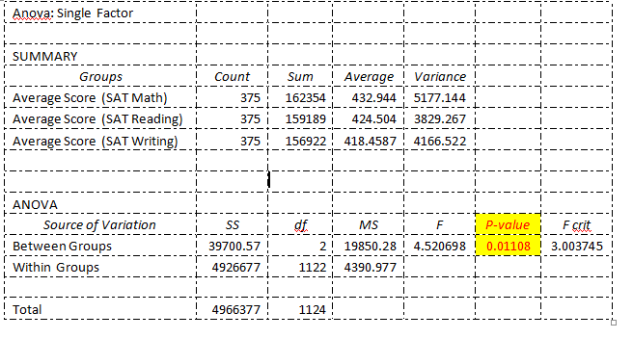

**B.Perform testing of hypothesis using Two-way ANOVA.**

#### Program Code:

import pandas as pd

import statsmodels.api as sm

from statsmodels.formula.api import ols

from statsmodels.stats.anova import anova_lm

from statsmodels.graphics.factorplots import interaction_plot import matplotlib.pyplot as plt

from scipy import stats

def eta_squared(aov): aov['eta_sq'] = 'NaN'

aov['eta_sq'] = aov[:-1]['sum_sq']/sum(aov['sum_sq']) return aov

def omega_squared(aov):

mse = aov['sum_sq'][-1]/aov['df'][-1] aov['omega_sq'] = 'NaN'

aov['omega_sq'] = (aov[:-1]['sum_sq']-(aov[:-

1]['df']*mse))/(sum(aov['sum_sq'])+mse) return aov

datafile = "ToothGrowth.csv" data = pd.read_csv(datafile)

fig = interaction_plot(data.dose, data.supp, data.len, colors=['red','blue'], markers=['D','^'], ms=10)

N = len(data.len)

df_a = len(data.supp.unique()) - 1 df_b = len(data.dose.unique()) - 1 df_axb = df_a*df_b

df_w = N - (len(data.supp.unique())*len(data.dose.unique())) grand_mean = data['len'].mean()

#Sum of Squares A – supp

ssq_a = sum([(data[data.supp ==l].len.mean()-grand_mean)**2 for l in data.supp]) #Sum of Squares B – supp

ssq_b = sum([(data[data.dose ==l].len.mean()-grand_mean)**2 for l in data.dose]) #Sum of Squares Total

ssq_t = sum((data.len - grand_mean)**2) vc = data[data.supp == 'VC']

oj = data[data.supp == 'OJ']

vc_dose_means = [vc[vc.dose == d].len.mean() for d in vc.dose]

oj_dose_means = [oj[oj.dose == d].len.mean() for d in oj.dose]

ssq_w = sum((oj.len - oj_dose_means)**2) +sum((vc.len - vc_dose_means)**2) ssq_axb = ssq_t-ssq_a-ssq_b-ssq_w

ms_a = ssq_a/df_a #Mean Square A ms_b = ssq_b/df_b #Mean Square B

ms_axb = ssq_axb/df_axb #Mean Square AXB ms_w = ssq_w/df_w

f_a = ms_a/ms_w f_b = ms_b/ms_w

f_axb = ms_axb/ms_w

p_a = stats.f.sf(f_a, df_a, df_w) p_b = stats.f.sf(f_b, df_b, df_w)

p_axb = stats.f.sf(f_axb, df_axb, df_w)

results = {'sum_sq':[ssq_a, ssq_b, ssq_axb, ssq_w], 'df':[df_a, df_b, df_axb, df_w],

'F':[f_a, f_b, f_axb, 'NaN'],

'PR(>F)':[p_a, p_b, p_axb, 'NaN']}

columns=['sum_sq', 'df', 'F', 'PR(>F)']

aov_table1 = pd.DataFrame(results, columns=columns, index=['supp', 'dose',

'supp:dose', 'Residual'])

formula = 'len ~ C(supp) + C(dose) + C(supp):C(dose)' model = ols(formula, data).fit()

aov_table = anova_lm(model, typ=2) eta_squared(aov_table) omega_squared(aov_table) print(aov_table.round(4))

res = model.resid

fig = sm.qqplot(res, line='s') plt.show()

## Output:

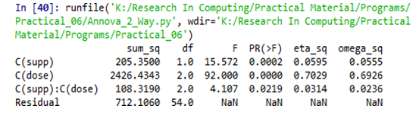

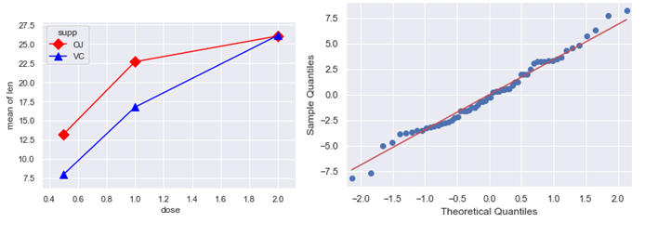

## Using Excel:

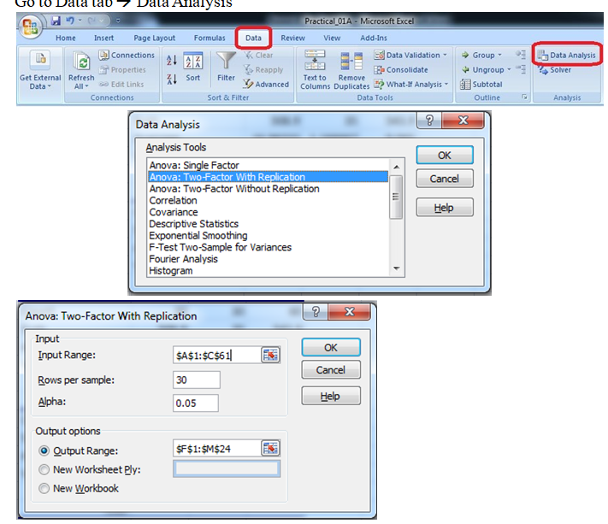

## Output:

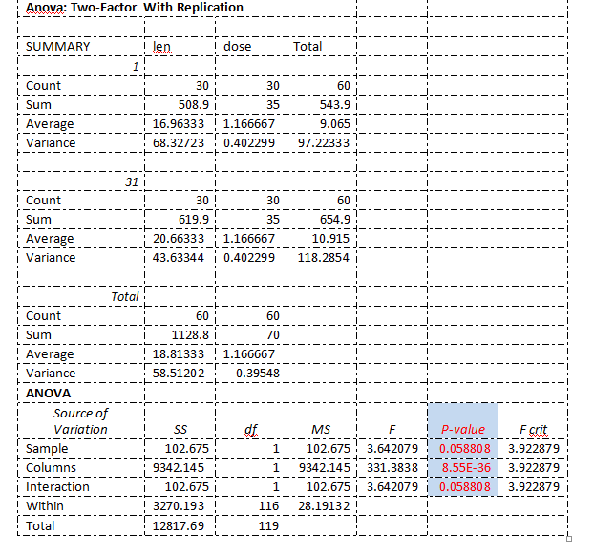

## C.Perform testing of hypothesis using MANOVA.

#### Code:

import pandas as pd

fromstatsmodels.multivariate.manova import MANOVA

df = pd.read_csv('iris.csv', index_col=0)

df.columns = df.columns.str.replace(".", "_")

df.head()

print('~~~~~~~~ Data Set ~~~~~~~~')

print(df)

maov = MANOVA.from_formula('Sepal_Length + Sepal_Width + \ Petal_Length + Petal_Width ~ Species', data=df)

print('~~~~~~~~ MANOVA Test Result ~~~~~~~~') print(maov.mv_test())

**Output:**

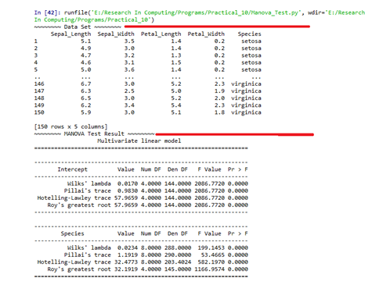

# Excel:

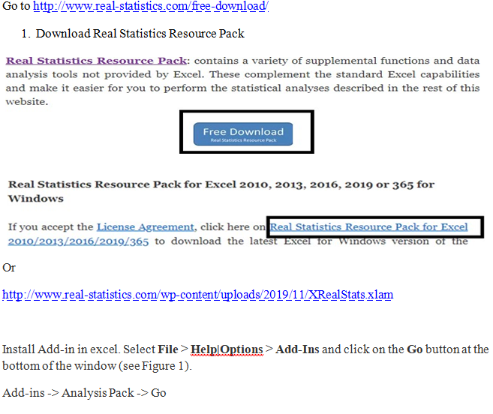

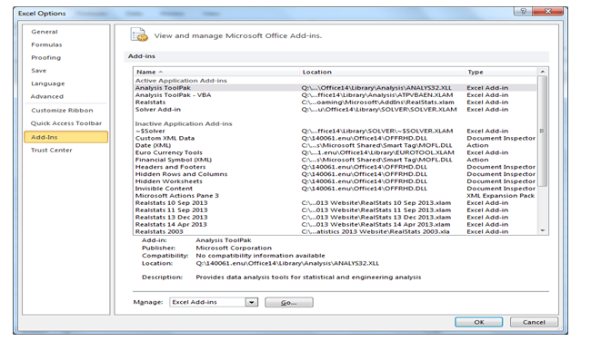

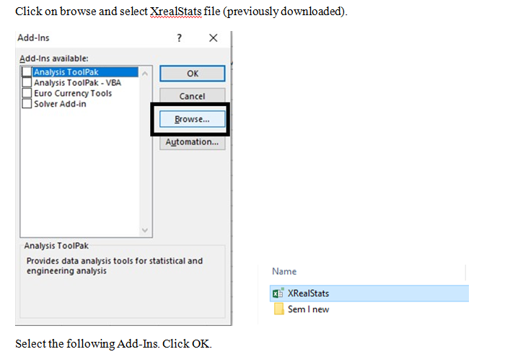

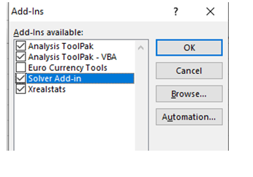

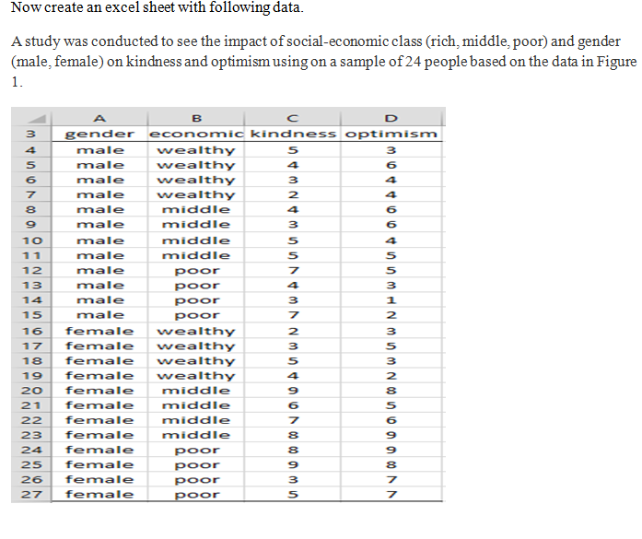

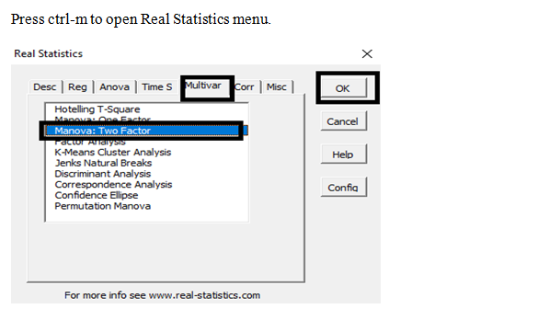

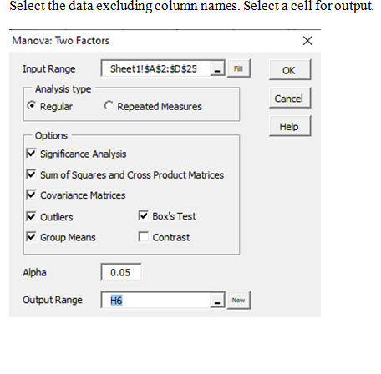

**Output:**

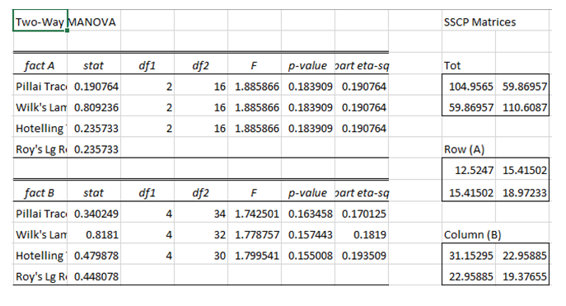

# Practical 7:

## Perform the Random sampling for the given data and analyse it.

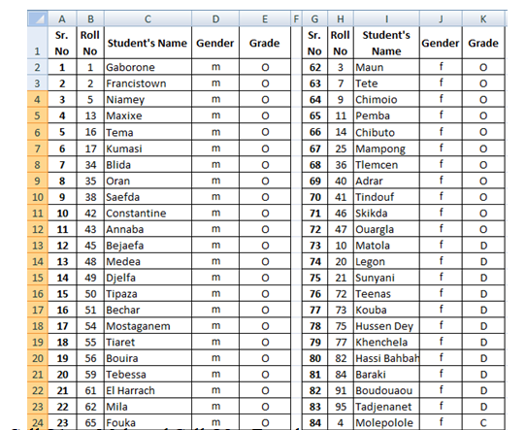

#### Output:

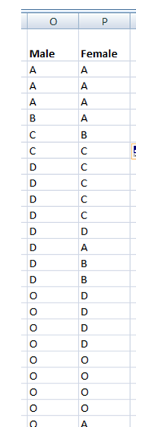

## B.Perform the Stratified sampling for the given data and analyse it.

#### Program Code:

import pandas as pd importnumpy as np

importmatplotlib importmatplotlib.pyplot as plt

plt.rcParams['axes.labelsize'] = 14

plt.rcParams['xtick.labelsize'] = 12

plt.rcParams['ytick.labelsize'] = 12

importseaborn as sns color = sns.color_palette() sns.set_style('darkgrid')

importsklearn

fromsklearn.model_selection import train_test_split

housing =pd.read_csv('housing.csv')

print(housing.head())

print(housing.info())

#creating a heatmap of the attributes in the dataset

correlation_matrix = housing.corr()

plt.subplots(figsize=(8,6))

sns.heatmap(correlation_matrix, center=0, annot=True, linewidths=.3)

corr =housing.corr() print(corr['median_house_value'].sort_values(ascending=False))

sns.distplot(housing.median_income) plt.show()

**Output:**

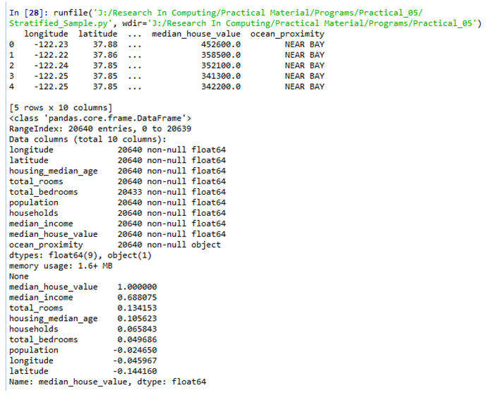

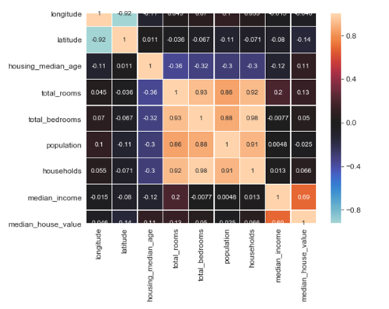

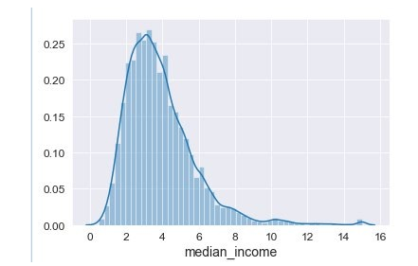

# Practical 8:

## Write a program for computing different correlation.

#### Code:

importnumpy as np

importmatplotlib.pyplot as plt

np.random.seed(1)

# 1000 random integers between 0 and 50

x = np.random.randint(0, 50, 1000)

# Positive Correlation with some noise

y = x + np.random.normal(0, 10, 1000)

np.corrcoef(x, y)

matplotlib.style.use('ggplot')

plt.scatter(x, y)

plt.show()

#### Output:

#### 

**Negative Correlation:**

importnumpy as np

importmatplotlib.pyplot as plt

np.random.seed(1)

# 1000 random integers between 0 and 50

x = np.random.randint(0, 50, 1000)

# Negative Correlation with some noise

y = 100 - x + np.random.normal(0, 5, 1000)

np.corrcoef(x, y)

plt.scatter(x, y)

plt.show()

#### Output:

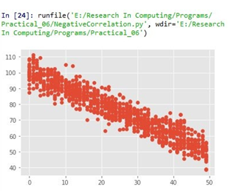

**No/Weak Correlation:**

importnumpy as np

importmatplotlib.pyplot as plt

np.random.seed(1)

x = np.random.randint(0, 50, 1000)

y = np.random.randint(0, 50, 1000)

np.corrcoef(x, y)

plt.scatter(x, y)

plt.show()

**Output:**

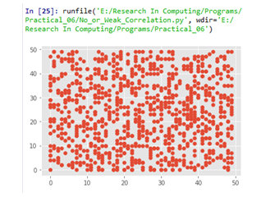

# Practical 9:

## Write a program to Perform linear regression for prediction.

import Quandl, math

import numpy as np

import pandas as pd

from sklearn import preprocessing, cross_validation, svm

from sklearn.linear_model import LinearRegression

import matplotlib.pyplot as plt

from matplotlib import style import datetime

style.use('ggplot')

df = Quandl.get("WIKI/GOOGL")

df = df[['Adj. Open', 'Adj. High', 'Adj. Low', 'Adj. Close', 'Adj. Volume']]

df['HL_PCT'] = (df['Adj. High'] - df['Adj. Low']) / df['Adj. Close'] * 100.0

df['PCT_change'] = (df['Adj. Close'] - df['Adj. Open']) / df['Adj. Open'] * 100.0

df = df[['Adj. Close', 'HL_PCT', 'PCT_change', 'Adj. Volume']]

forecast_col = 'Adj. Close'

df.fillna(value=-99999, inplace=True)

forecast_out = int(math.ceil(0.01 * len(df)))

df['label'] = df[forecast_col].shift(-forecast_out)

X = np.array(df.drop(['label'], 1))

X = preprocessing.scale(X)

X_lately = X[-forecast_out:]

X = X[:-forecast_out]

df.dropna(inplace=True)

y = np.array(df['label'])

X_train, X_test, y_train, y_test = cross_validation.train_test_split(X, y, test_size=0.2)

clf = LinearRegression(n_jobs=-1)

clf.fit(X_train, y_train)

confidence = clf.score(X_test, y_test)

forecast_set = clf.predict(X_lately)

df['Forecast'] = np.nan

last_date = df.iloc[-1].name

last_unix = last_date.timestamp()

one_day = 86400

next_unix = last_unix + one_day

for i in forecast_set:

next_date = datetime.datetime.fromtimestamp(next_unix)

next_unix += 86400

df.loc[next_date] = [np.nan for _ in range(len(df.columns)-1)]+[i]

df['Adj. Close'].plot()

df['Forecast'].plot()

plt.legend(loc=4)

plt.xlabel('Date')

plt.ylabel('Price')

plt.show()

### Output:

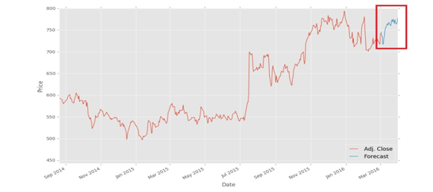

## Perform polynomial regression for prediction.

importnumpy as np

importmatplotlib.pyplot as plt

defestimate_coef(x, y):

# number of observations/points

n = np.size(x)

# mean of x and y vector

m_x, m_y = np.mean(x), np.mean(y)

# calculating cross-deviation and deviation about x

SS_xy = np.sum(y*x) - n*m_y*m_x

SS_xx = np.sum(x*x) - n*m_x*m_x

# calculating regression coefficients

b_1 = SS_xy / SS_xx

b_0 = m_y - b_1*m_x

return(b_0, b_1)

defplot_regression_line(x, y, b):

# plotting the actual points as scatter plot

plt.scatter(x, y, color = "m",

marker = "o", s = 30)

# predicted response vector

y_pred = b[0] + b[1]*x

# plotting the regression line

plt.plot(x, y_pred, color = "g")

# putting labels

plt.xlabel('x')

plt.ylabel('y')

# function to show plot

plt.show()

def main():

# observations

x = np.array([0, 1, 2, 3, 4, 5, 6, 7, 8, 9])

y = np.array([1, 3, 2, 5, 7, 8, 8, 9, 10, 12])

# estimating coefficients

b = estimate_coef(x, y)

print("Estimated coefficients:\nb_0 = {} b_1 = {}".format(b[0], b[1]))

# plotting regression line

plot_regression_line(x, y, b)

if name == " main ":

main()

**Output:**

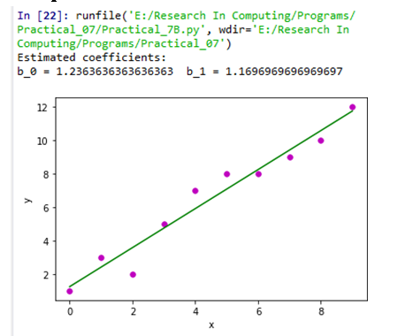

# Practical 10:

## Write a program for multiple linear regression analysis.

importnumpy as np

importmatplotlib as mpl

from mpl_toolkits.mplot3d import Axes3D

importmatplotlib.pyplot as plt

defgenerate_dataset(n):

x = []

y = []

random_x1 = np.random.rand()

random_x2 = np.random.rand()

for i in range(n):

x1 = i

x2 = i/2 + np.random.rand()*n

x.append([1, x1, x2])

y.append(random_x1 * x1 + random_x2 * x2 + 1)

returnnp.array(x), np.array(y)

x, y = generate_dataset(200)

mpl.rcParams['legend.fontsize'] = 12

fig = plt.figure()

ax = fig.gca(projection ='3d')

ax.scatter(x[:, 1], x[:, 2], y, label ='y', s = 5)

ax.legend()

ax.view_init(45, 0)

plt.show()

defmse(coef, x, y):

returnnp.mean((np.dot(x, coef) - y)**2)

def gradients(coef, x, y):

returnnp.mean(x.transpose()*(np.dot(x, coef) - y), axis = 1)

defmultilinear_regression(coef, x, y, lr, b1 = 0.9, b2 = 0.999, epsilon = 1e-8):

prev_error = 0

m_coef = np.zeros(coef.shape)

v_coef = np.zeros(coef.shape)

moment_m_coef = np.zeros(coef.shape)

moment_v_coef = np.zeros(coef.shape)

t = 0

while True:

error = mse(coef, x, y)

if abs(error - prev_error) <= epsilon:

break

prev_error = error

grad = gradients(coef, x, y) t += 1

m_coef = b1 * m_coef + (1-b1)*grad

v_coef = b2 * v_coef + (1-b2)*grad**2

moment_m_coef = m_coef / (1-b1**t)

moment_v_coef = v_coef / (1-b2**t)

delta = ((lr / moment_v_coef**0.5 + 1e-8) *

(b1 * moment_m_coef + (1-b1)*grad/(1-b1**t)))

coef = np.subtract(coef, delta)

returncoef

coef = np.array([0, 0, 0])

c = multilinear_regression(coef, x, y, 1e-1) fig = plt.figure()

ax = fig.gca(projection ='3d')

ax.scatter(x[:, 1], x[:, 2], y, label ='y',

s = 5, color ="dodgerblue")

ax.scatter(x[:, 1], x[:, 2], c[0] + c[1]*x[:, 1] + c[2]*x[:, 2],

label ='regression', s = 5, color ="orange")

ax.view_init(45, 0)

ax.legend()

plt.show()

# Output:

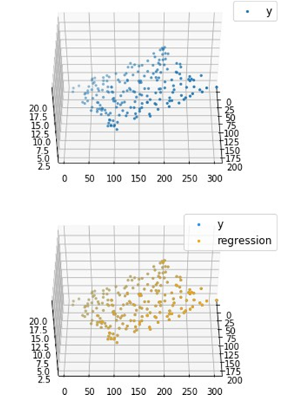

## Perform logistic regression analysis.

### Program Code:

import os

import numpy as np

import pandas as pd

import matplotlib

import matplotlib.pyplot as plt

import scipy.stats as stats

from sklearn import linear_model

from sklearn import preprocessing

from sklearn import metrics

matplotlib.style.use('ggplot')

plt.figure(figsize=(9,9))

def sigmoid(t): # Define the sigmoid function

return (1/(1 + np.e**(-t)))

plot_range = np.arange(-6, 6, 0.1)

y_values = sigmoid(plot_range)

# Plot curve

plt.plot(plot_range, # X-axis range

y_values, # Predicted values

color="red")

titanic_train = pd.read_csv("titanic_train.csv") # Read the data

char_cabin = titanic_train["Cabin"].astype(str) # Convert cabin to str

new_Cabin = np.array([cabin[0] for cabin in char_cabin]) # Take first letter

titanic_train["Cabin"] = pd.Categorical(new_Cabin) # Save the new cabin var

# Impute median Age for NA Age values

new_age_var = np.where(titanic_train["Age"].isnull(), # Logical check 28, # Value if check is true

titanic_train["Age"]) # Value if check is false titanic_train["Age"] = new_age_var

label_encoder = preprocessing.LabelEncoder()

# Convert Sex variable to numeric

encoded_sex = label_encoder.fit_transform(titanic_train["Sex"])

# Initialize logistic regression model

log_model = linear_model.LogisticRegression()

# Train the model

log_model.fit(X = pd.DataFrame(encoded_sex), y = titanic_train["Survived"])

# Check trained model intercept print(log_model.intercept_)

# Check trained model coefficients print(log_model.coef_)

# Make predictions

preds = log_model.predict_proba(X= pd.DataFrame(encoded_sex))

preds = pd.DataFrame(preds)

preds.columns = ["Death_prob", "Survival_prob"]

# Generate table of predictions vs Sex

pd.crosstab(titanic_train["Sex"], preds.ix[:, "Survival_prob"])

# Convert more variables to numeric

encoded_class = label_encoder.fit_transform(titanic_train["Pclass"])

encoded_cabin = label_encoder.fit_transform(titanic_train["Cabin"])

train_features = pd.DataFrame([encoded_class,

encoded_cabin,

encoded_sex, titanic_train["Age"]]).T

# Initialize logistic regression model

log_model = linear_model.LogisticRegression()

# Train the model

log_model.fit(X = train_features ,

y = titanic_train["Survived"])

# Check trained model intercept

print(log_model.intercept_)

# Check trained model coefficients

print(log_model.coef_)

# Make predictions

preds = log_model.predict(X= train_features)

# Generate table of predictions vs actual

pd.crosstab(preds,titanic_train["Survived"])

log_model.score(X = train_features ,

y = titanic_train["Survived"])

metrics.confusion_matrix(y_true=titanic_train["Survived"],

# True labels y_pred=preds) # Predicted labels

# View summary of common classification metrics

print(metrics.classification_report(y_true=titanic_train["Survived"],

y_pred=preds) )

# Read and prepare test data

titanic_test = pd.read_csv("titanic_test.csv") # Read the data

char_cabin = titanic_test["Cabin"].astype(str) # Convert cabin to str

new_Cabin = np.array([cabin[0] for cabin in char_cabin]) # Take first letter

titanic_test["Cabin"] = pd.Categorical(new_Cabin) # Save the new cabin var

# Impute median Age for NA Age values

new_age_var = np.where(titanic_test["Age"].isnull(),28,titanic_test["Age"])

titanic_test["Age"] = new_age_var

# Convert test variables to match model features

encoded_sex = label_encoder.fit_transform(titanic_test["Sex"])

encoded_class = label_encoder.fit_transform(titanic_test["Pclass"])

encoded_cabin = label_encoder.fit_transform(titanic_test["Cabin"])

test_features = pd.DataFrame([encoded_class,encoded_cabin,encoded_sex,titanic_test["Age"]]).T

# Make test set predictions

test_preds = log_model.predict(X=test_features)

# Create a submission for Kaggle

submission = pd.DataFrame({"PassengerId":titanic_test["PassengerId"], "Survived":test_preds})

# Save submission to CSV submission.to_csv("tutorial_logreg_submission.csv",

index=False) # Do not save index values

print(pd)

### Output:

